Conic Loci

Definition
# Source: AI Source: Provided by: [Data Path: Persons Table -> ID Column: 1, Name_En Column: Motasem Essam] -> From: [ChatGPT] on [7/25/2026]
Conic loci are loci formed by points in a plane that satisfy specific distance relationships involving fixed points, fixed lines, or both.
The four fundamental nondegenerate conic types are:
$$\boxed{\text{Circle, Ellipse, Parabola, Hyperbola}}$$
Each can be defined geometrically as a locus.
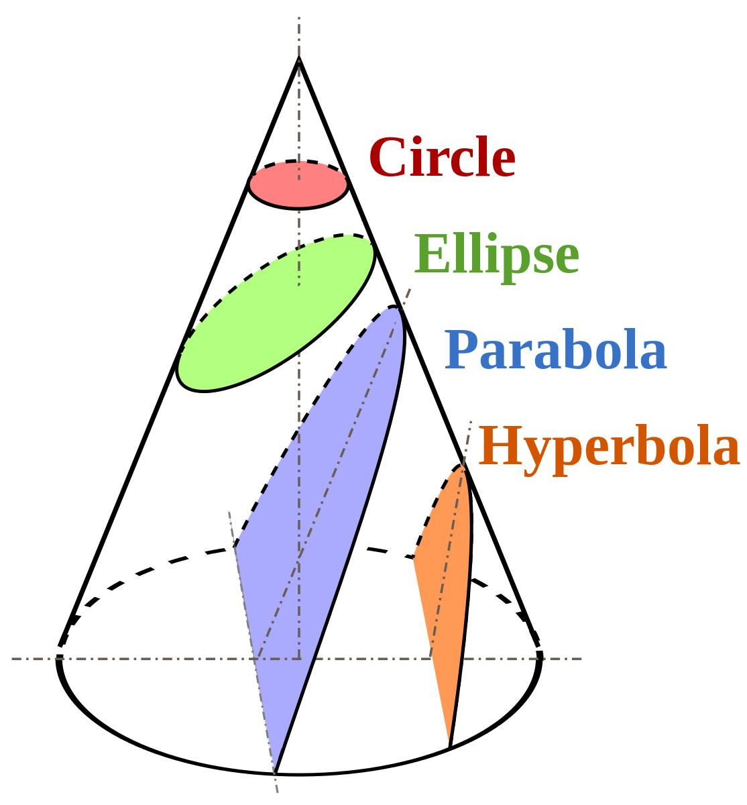
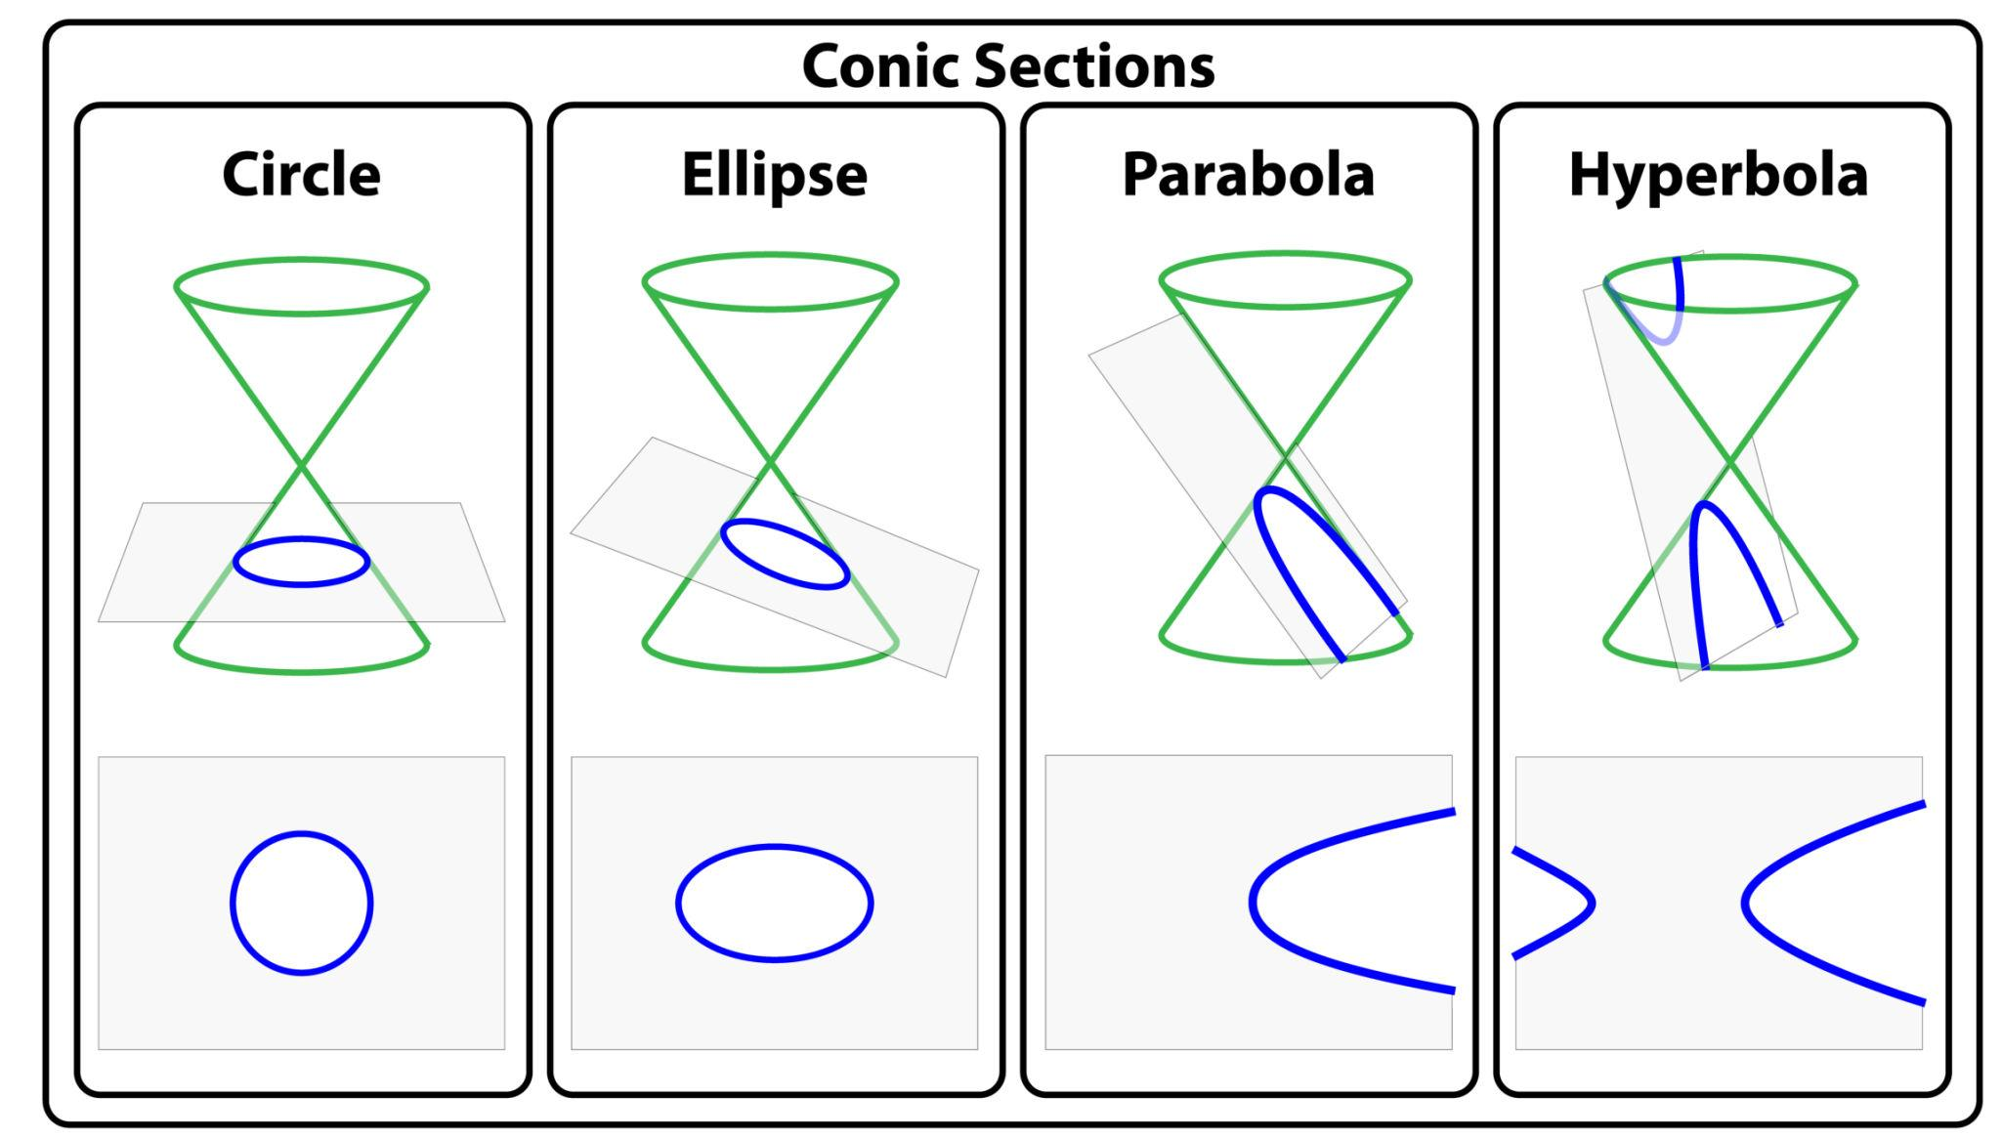
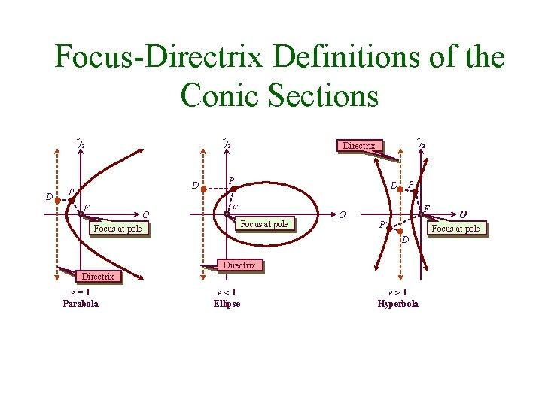
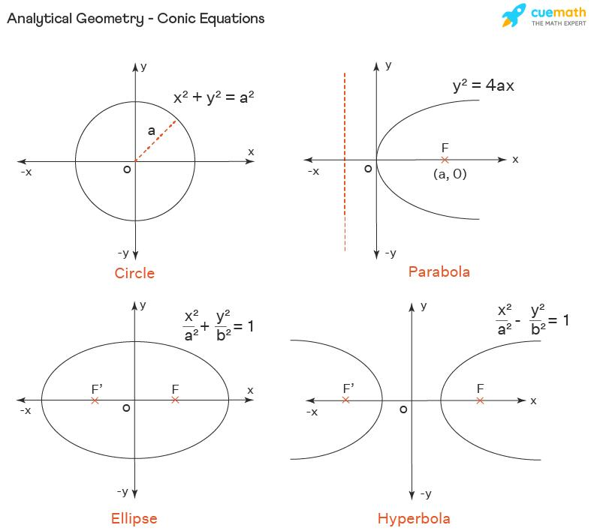

Simple Definition
# Source: AI Source: Provided by: [Data Path: Persons Table -> ID Column: 1, Name_En Column: Motasem Essam] -> From: [ChatGPT] on [7/25/2026]
A conic locus is the set of points satisfying a particular distance condition that produces a circle, ellipse, parabola, or hyperbola.
The fundamental distance definitions are:
$$\boxed{\begin{aligned}\text{Circle}&→\text{fixed distance from a point} \\ \text{Ellipse}&→\text{constant sum of distances from two points} \\ \text{Parabola}&→\text{equal distance from a point and a line} \\ \text{Hyperbola}&→\text{constant difference of distances from two points}\end{aligned}}$$

Fundamental Concept
# Source: AI Source: Provided by: [Data Path: Persons Table -> ID Column: 1, Name_En Column: Motasem Essam] -> From: [ChatGPT] on [7/25/2026]
A locus is generated by a condition imposed on a variable point $P$.
For conic loci, the condition is based on distances.
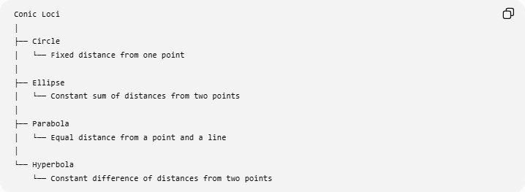
Conic Loci
│
├── Circle
│ └── Fixed distance from one point
│
├── Ellipse
│ └── Constant sum of distances from two points
│
├── Parabola
│ └── Equal distance from a point and a line
│
└── Hyperbola
└── Constant difference of distances from two points
Thus, conic loci can be understood through their defining distance relationships.

Main Types of Conic Loci
# Source: AI Source: Provided by: [Data Path: Persons Table -> ID Column: 1, Name_En Column: Motasem Essam] -> From: [ChatGPT] on [7/25/2026]
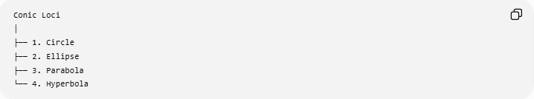
Conic Loci
│
├── 1. Circle
├── 2. Ellipse
├── 3. Parabola
└── 4. Hyperbola
These are the four standard nondegenerate conic sections.

Circle as a Conic Locus
# Source: AI Source: Provided by: [Data Path: Persons Table -> ID Column: 1, Name_En Column: Motasem Essam] -> From: [ChatGPT] on [7/25/2026]
Definition
A circle is the locus of all points at a fixed distance from a fixed point.
If $O$is the center and $r$is the radius:
$$\boxed{OP=r}$$
where $P$is the variable point.
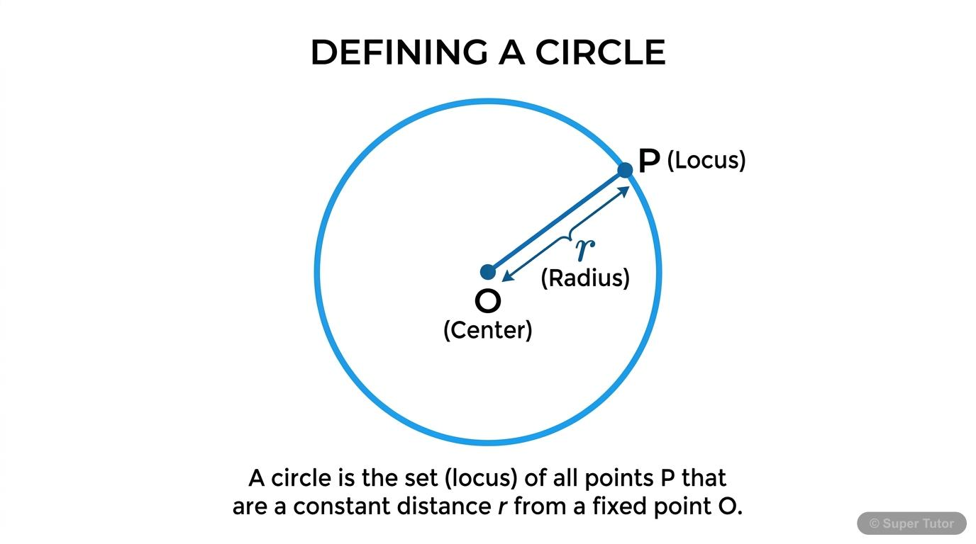
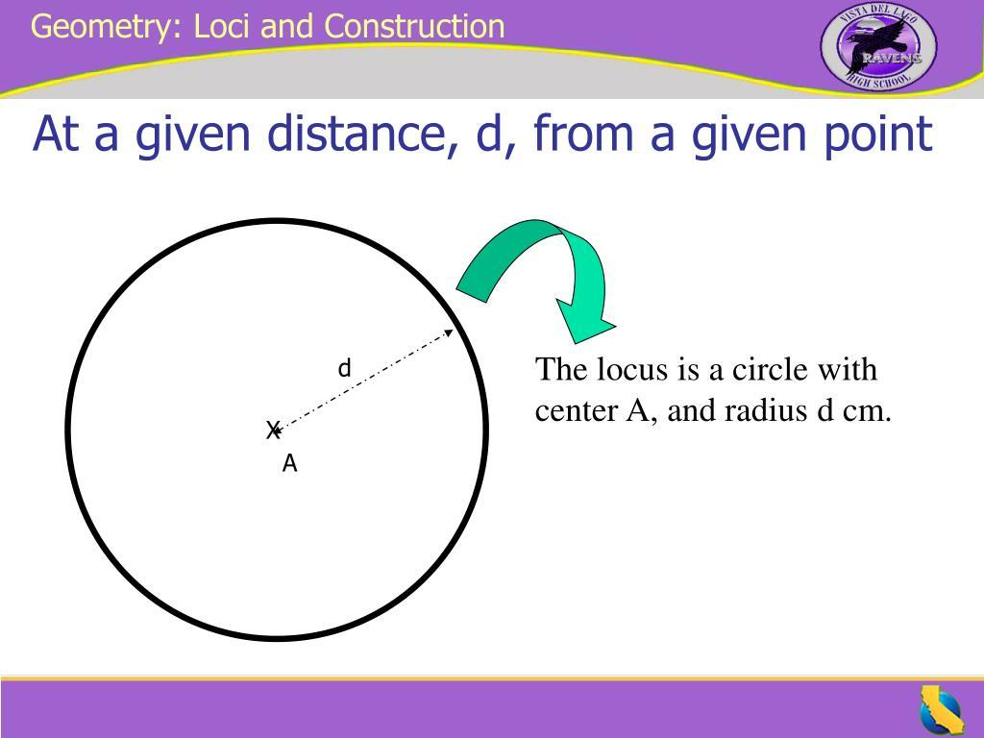
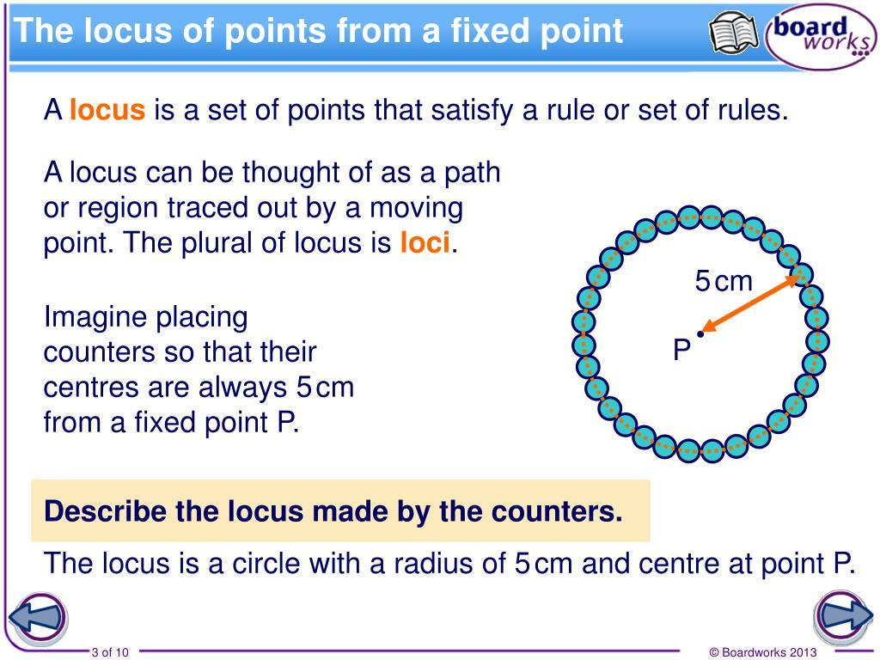
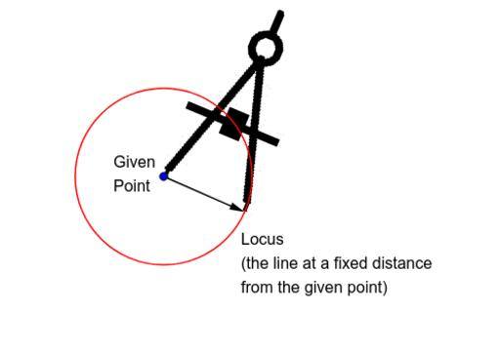
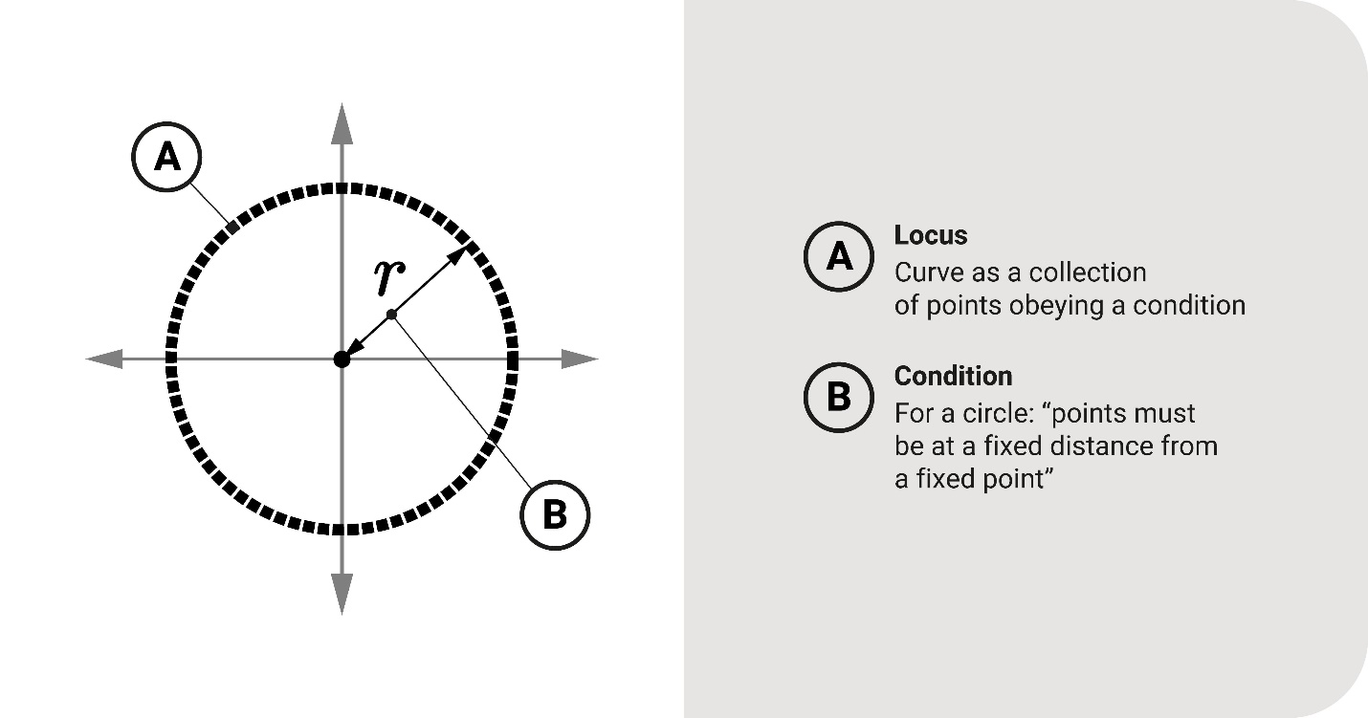
Example
If:
$$O=\left(0 , 0\right)$$
and:
$$r=5,$$
then:
$$\boxed{x^{2}+y^{2}=25}.$$
Every point satisfying this equation is exactly $5$units from $O$.
Classification
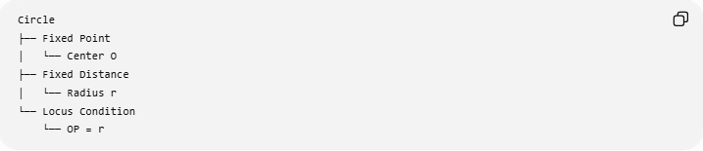
Circle
├── Fixed Point
│ └── Center O
├── Fixed Distance
│ └── Radius r
└── Locus Condition
└── OP = r

Ellipse as a Conic Locus
# Source: AI Source: Provided by: [Data Path: Persons Table -> ID Column: 1, Name_En Column: Motasem Essam] -> From: [ChatGPT] on [7/25/2026]
Definition
An ellipse is the locus of all points for which the sum of the distances to two fixed points is constant.
The fixed points are the foci $F_{1},F_{2}$.
$$\boxed{PF_{1}+PF_{2}=2a}$$
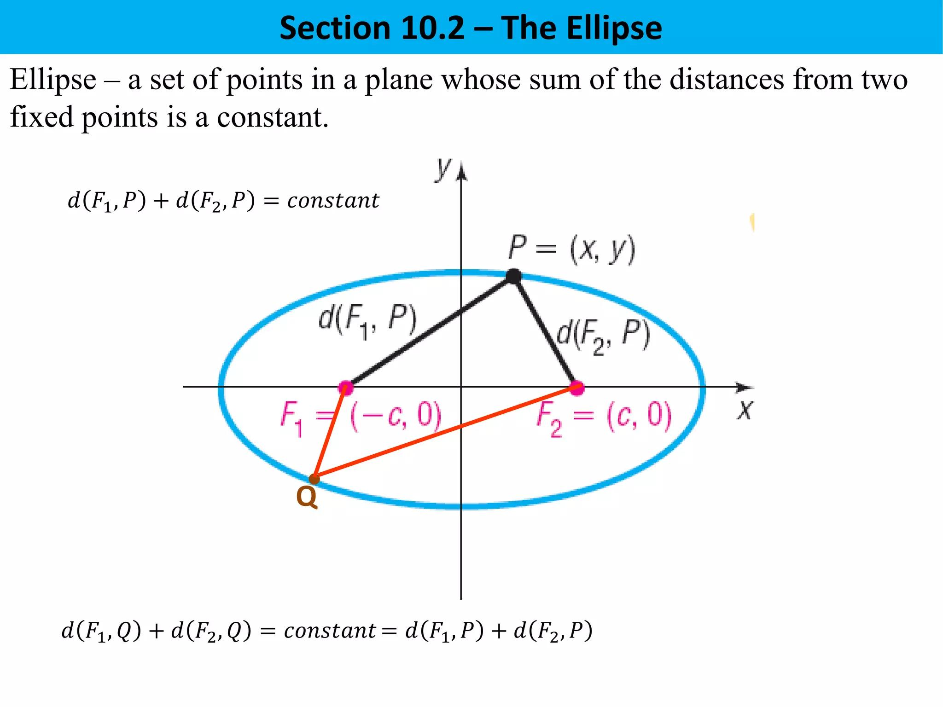
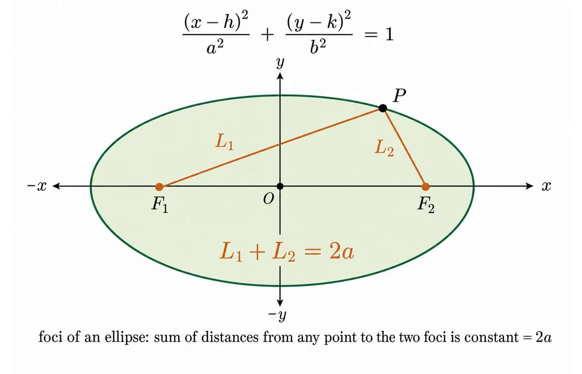
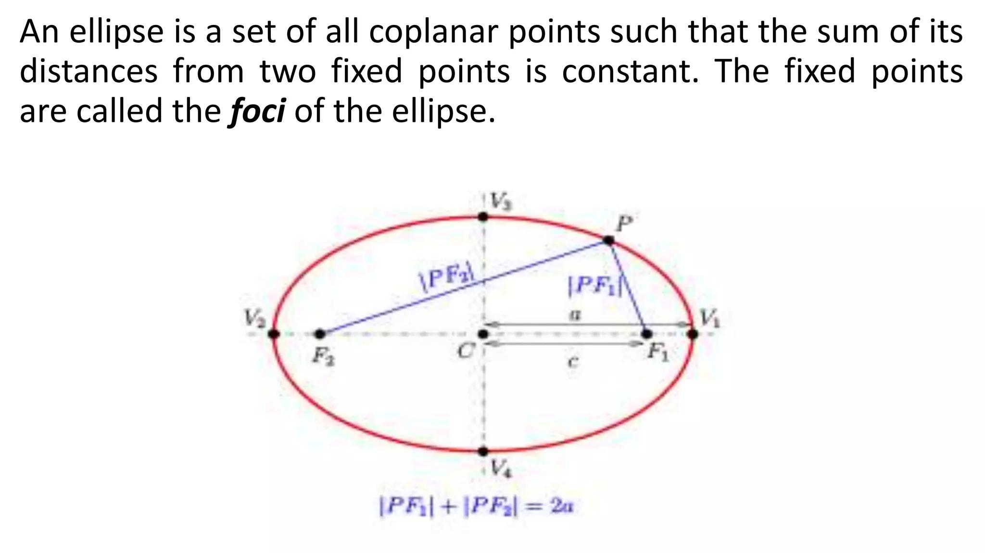
Example
If:
$$PF_{1}+PF_{2}=20,$$
then the locus is an ellipse with:
$$2a=20$$
and therefore:
$$a=10.$$
Fundamental relationship
For an ellipse:
$$\boxed{c^{2}=a^{2}-b^{2}}$$
where:
- $a$= semi-major axis
- $b$= semi-minor axis
- $c$= center-to-focus distance
Classification
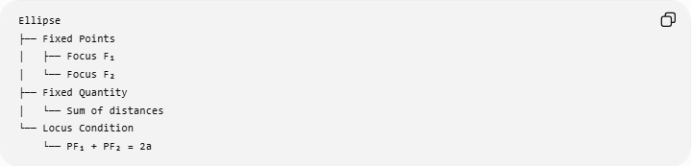
Ellipse
├── Fixed Points
│ ├── Focus F₁
│ └── Focus F₂
├── Fixed Quantity
│ └── Sum of distances
└── Locus Condition
└── PF₁ + PF₂ = 2a

Parabola as a Conic Locus
# Source: AI Source: Provided by: [Data Path: Persons Table -> ID Column: 1, Name_En Column: Motasem Essam] -> From: [ChatGPT] on [7/25/2026]
Definition
A parabola is the locus of all points that are equidistant from a fixed point and a fixed line.
The fixed point is the focus, and the fixed line is the directrix.
$$\boxed{PF=d\left(P , l\right)}$$
where:
- $F$= focus
- $l$= directrix
- $P$= variable point
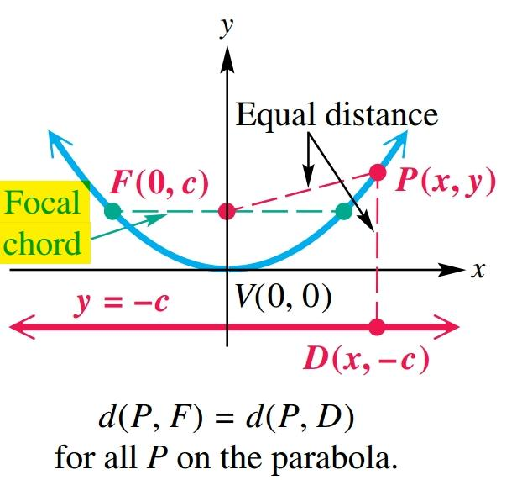
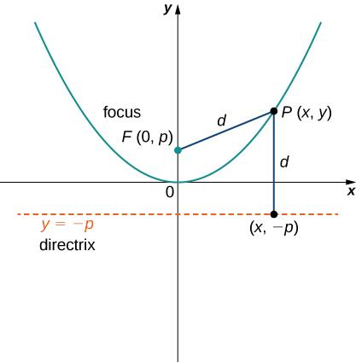
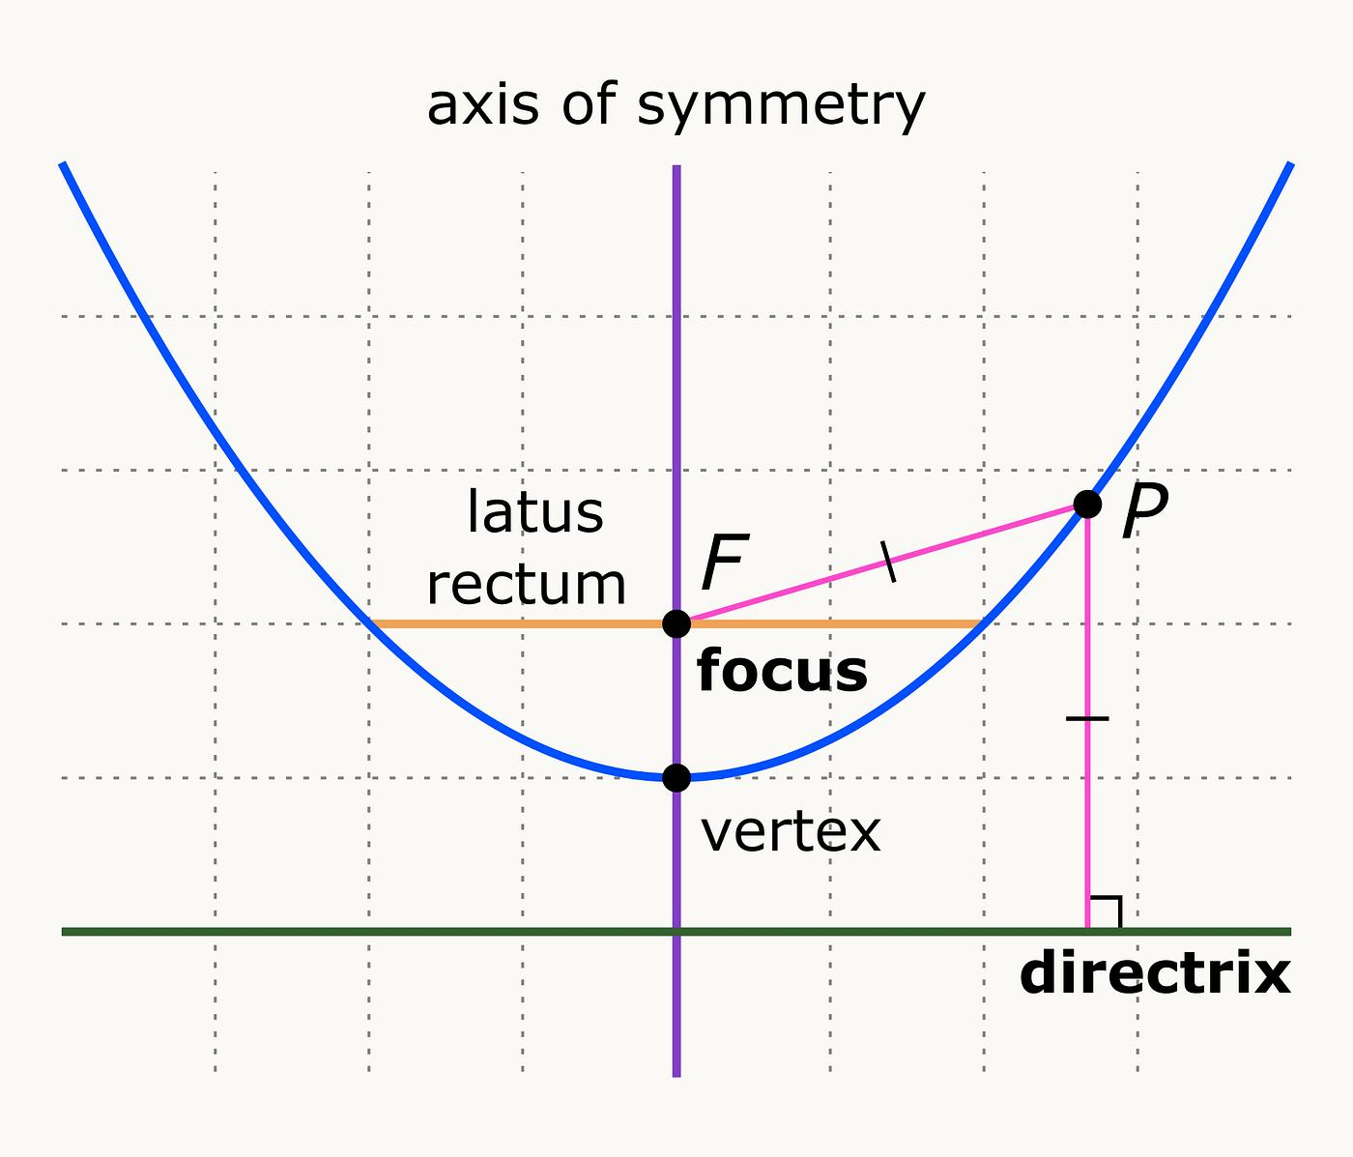
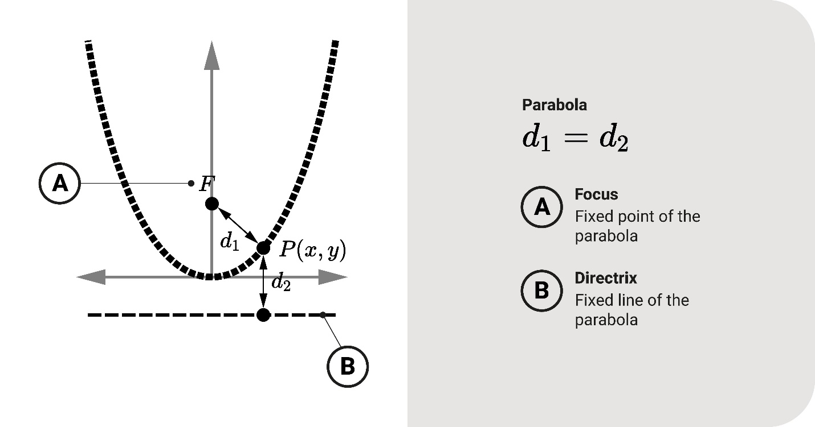
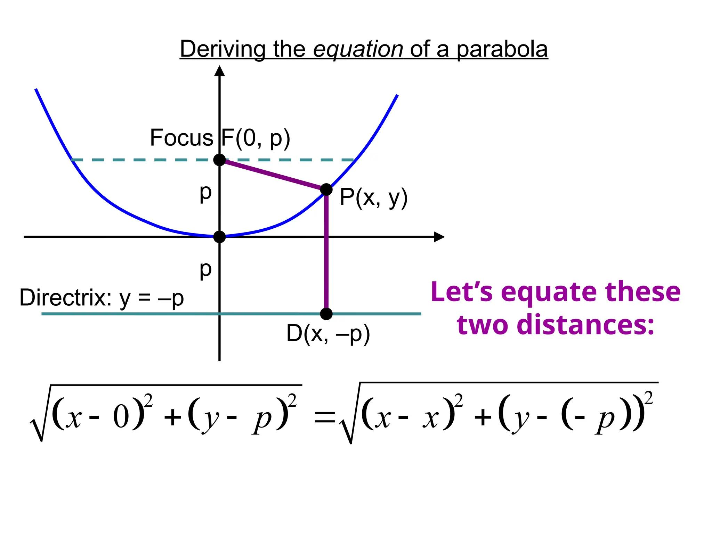
Example
If:
$$F=\left(0 , 2\right)$$
and:
$$l:y=-2,$$
then the locus condition is:
$$PF=d\left(P , l\right).$$
The resulting parabola is:
$$\boxed{x^{2}=8y}.$$
Classification
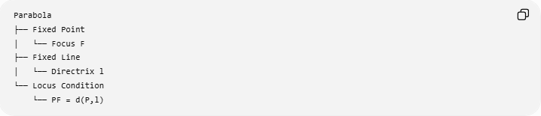
Parabola
├── Fixed Point
│ └── Focus F
├── Fixed Line
│ └── Directrix l
└── Locus Condition
└── PF = d(P,l)

Hyperbola as a Conic Locus
# Source: AI Source: Provided by: [Data Path: Persons Table -> ID Column: 1, Name_En Column: Motasem Essam] -> From: [ChatGPT] on [7/25/2026]
Definition
A hyperbola is the locus of all points for which the absolute difference between the distances to two fixed points is constant.
The fixed points are the foci.
$$\boxed{∣PF_{1}-PF_{2}∣=2a}$$
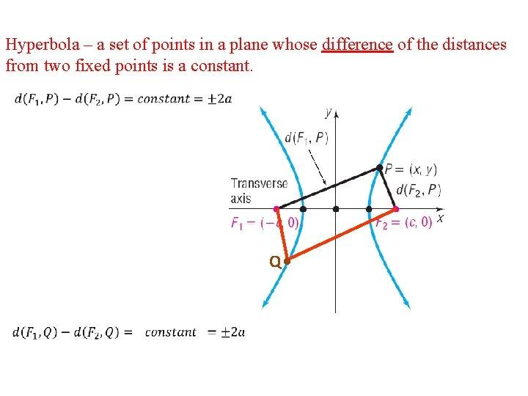
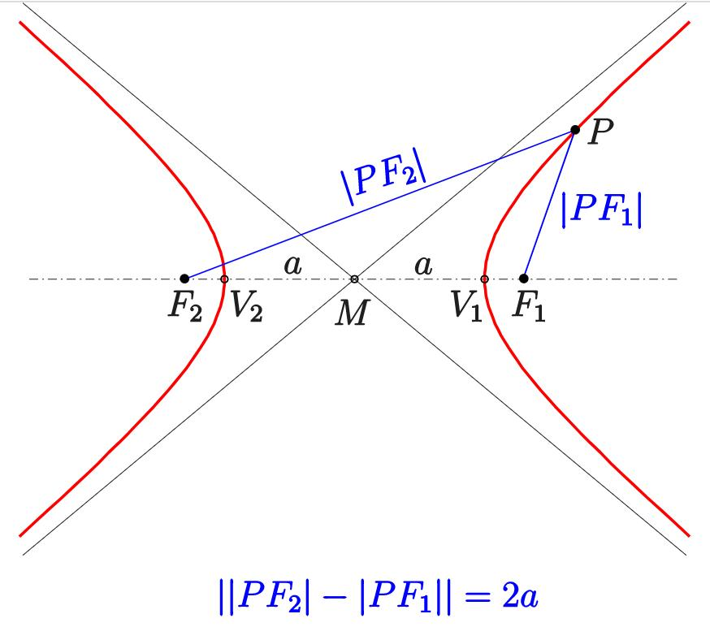
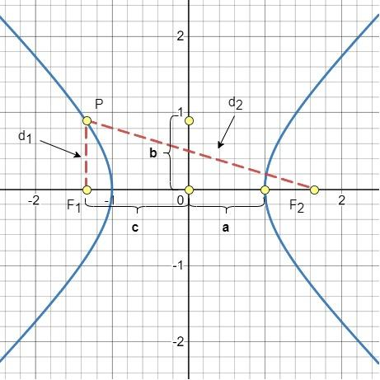
Example
Suppose:
$$∣PF_{1}-PF_{2}∣=8.$$
Then:
$$2a=8$$
and:
$$a=4.$$
The resulting locus is a hyperbola.
Fundamental relationship
$$\boxed{c^{2}=a^{2}+b^{2}}$$
Classification
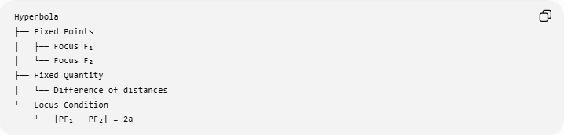
Hyperbola
├── Fixed Points
│ ├── Focus F₁
│ └── Focus F₂
├── Fixed Quantity
│ └── Difference of distances
└── Locus Condition
└── |PF₁ − PF₂| = 2a

Comparison of the Four Conic Loci
# Source: AI Source: Provided by: [Data Path: Persons Table -> ID Column: 1, Name_En Column: Motasem Essam] -> From: [ChatGPT] on [7/25/2026]
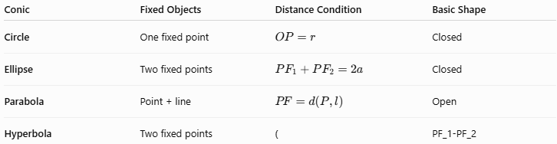
Conic | Fixed Objects | Distance Condition | Basic Shape
Circle | One fixed point | $$OP=r$$ | Closed
Ellipse | Two fixed points | $$PF_{1}+PF_{2}=2a$$ | Closed
Parabola | Point + line | $$PF=d\left(P , l\right)$$ | Open
Hyperbola | Two fixed points | ( | PF_1-PF_2
The most important distinction is the distance condition.

Conic Loci by Distance Relationship
# Source: AI Source: Provided by: [Data Path: Persons Table -> ID Column: 1, Name_En Column: Motasem Essam] -> From: [ChatGPT] on [7/25/2026]
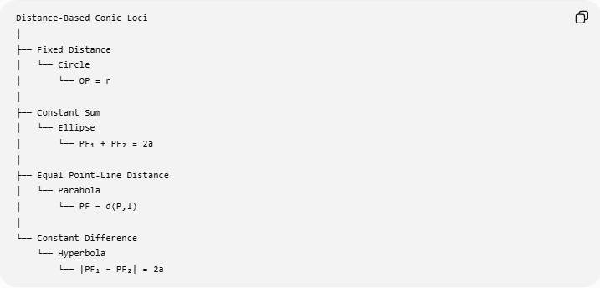
Distance-Based Conic Loci
│
├── Fixed Distance
│ └── Circle
│ └── OP = r
│
├── Constant Sum
│ └── Ellipse
│ └── PF₁ + PF₂ = 2a
│
├── Equal Point-Line Distance
│ └── Parabola
│ └── PF = d(P,l)
│
└── Constant Difference
└── Hyperbola
└── |PF₁ − PF₂| = 2a
This is one of the most useful ways to classify the conics from a locus perspective.

Conic Loci and Eccentricity
# Source: AI Source: Provided by: [Data Path: Persons Table -> ID Column: 1, Name_En Column: Motasem Essam] -> From: [ChatGPT] on [7/25/2026]
The four conics can also be classified using eccentricity $e$.
$$\boxed{\begin{matrix}\text{Conic} & \text{Eccentricity} \\ \text{Circle} & e=0 \\ \text{Ellipse} & 0<e<1 \\ \text{Parabola} & e=1 \\ \text{Hyperbola} & e>1\end{matrix}}$$
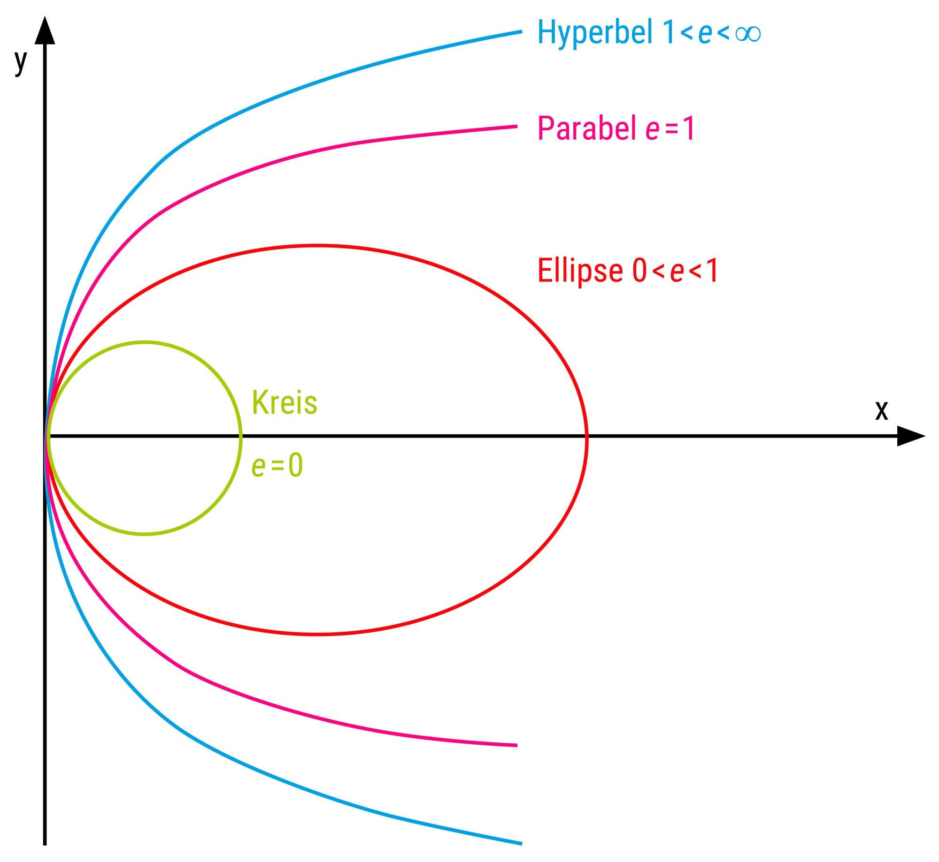
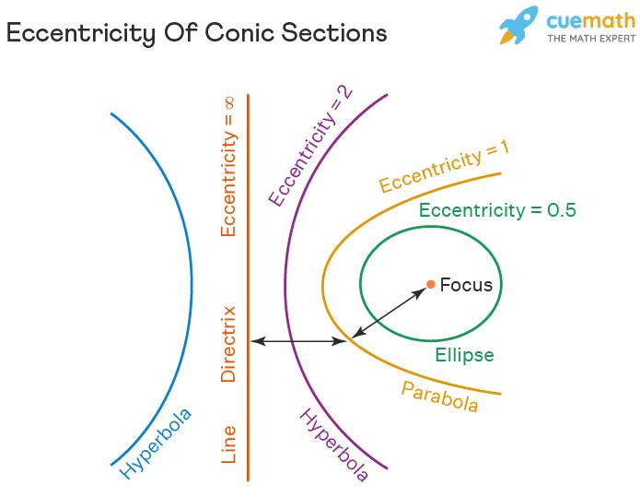
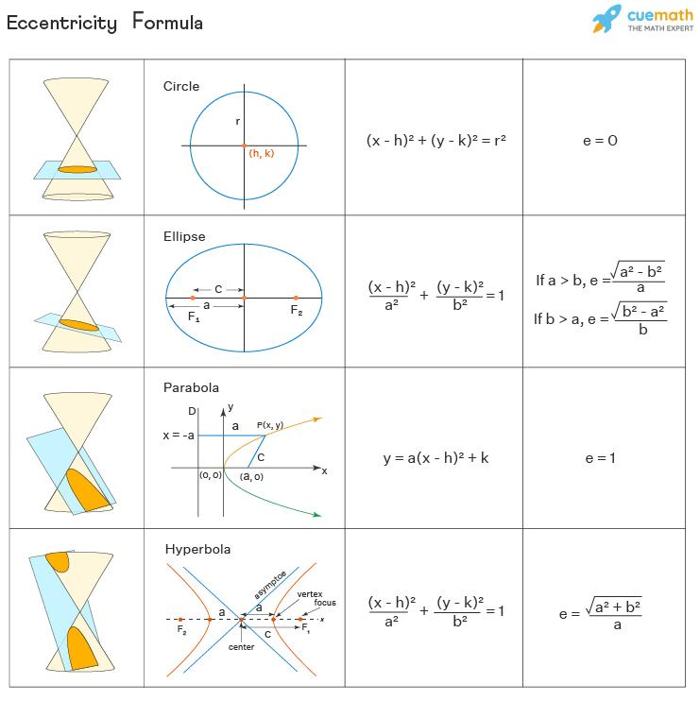
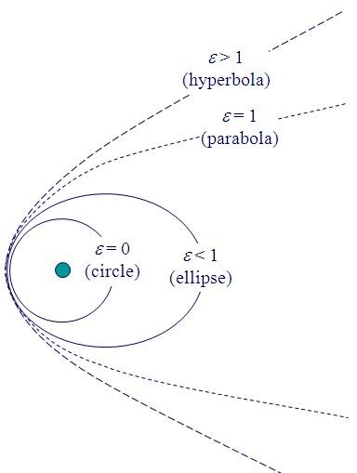
Thus:
$$\boxed{e<1→\text{Ellipse}} \\ \boxed{e=1→\text{Parabola}} \\ \boxed{e>1→\text{Hyperbola}}$$
The circle is the special case:
$$\boxed{e=0}.$$

Focus–Directrix Definition of Conics
# Source: AI Source: Provided by: [Data Path: Persons Table -> ID Column: 1, Name_En Column: Motasem Essam] -> From: [ChatGPT] on [7/25/2026]
A unified definition of conics uses a fixed focus and a fixed directrix.
For a point $P$:
$$\boxed{\frac{PF}{d\left(P , l\right)}=e}$$
where $e$is the eccentricity.
This produces:
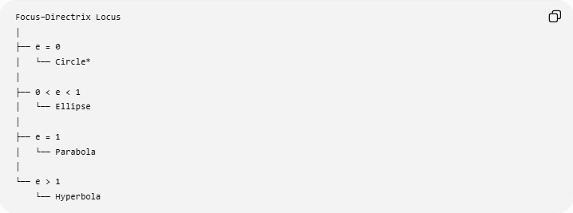
Focus–Directrix Locus
│
├── e = 0
│ └── Circle*
│
├── 0 < e < 1
│ └── Ellipse
│
├── e = 1
│ └── Parabola
│
└── e > 1
└── Hyperbola
$*$The circle is a special limiting/symmetric case in the focus-directrix framework; its standard elementary locus definition is more naturally $OP=r$.
For ellipse and hyperbola, there are corresponding focus-directrix descriptions.

Coordinate Equations
# Source: AI Source: Provided by: [Data Path: Persons Table -> ID Column: 1, Name_En Column: Motasem Essam] -> From: [ChatGPT] on [7/25/2026]
The standard coordinate equations are another way of representing conic loci.
Circle
$$\boxed{{\left(x-h\right)}^{2}+{\left(y-k\right)}^{2}=r^{2}}$$
Horizontal Ellipse
$$\boxed{\frac{{\left(x-h\right)}^{2}}{a^{2}}+\frac{{\left(y-k\right)}^{2}}{b^{2}}=1}$$
Horizontal Hyperbola
$$\boxed{\frac{{\left(x-h\right)}^{2}}{a^{2}}-\frac{{\left(y-k\right)}^{2}}{b^{2}}=1}$$
Vertical Ellipse
$$\boxed{\frac{{\left(x-h\right)}^{2}}{b^{2}}+\frac{{\left(y-k\right)}^{2}}{a^{2}}=1}$$
Vertical Hyperbola
$$\boxed{\frac{{\left(y-k\right)}^{2}}{a^{2}}-\frac{{\left(x-h\right)}^{2}}{b^{2}}=1}$$
Parabola
For a vertical parabola:
$$\boxed{{\left(x-h\right)}^{2}=4p\left(y-k\right)}$$
For a horizontal parabola:
$$\boxed{{\left(y-k\right)}^{2}=4p\left(x-h\right)}$$

Closed vs Open Conic Loci
# Source: AI Source: Provided by: [Data Path: Persons Table -> ID Column: 1, Name_En Column: Motasem Essam] -> From: [ChatGPT] on [7/25/2026]
The four conics can also be classified by whether they form closed curves.
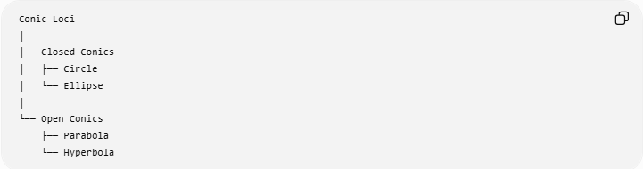
Conic Loci
│
├── Closed Conics
│ ├── Circle
│ └── Ellipse
│
└── Open Conics
├── Parabola
└── Hyperbola
Closed
Circle and ellipse are bounded:
$$\boxed{\text{Circle and Ellipse }\text{→} \text{Closed}}$$
Open
Parabola and hyperbola extend indefinitely:
$$\boxed{\text{Parabola and Hyperbola }\text{→} \text{Open}}$$

Number of Branches
# Source: AI Source: Provided by: [Data Path: Persons Table -> ID Column: 1, Name_En Column: Motasem Essam] -> From: [ChatGPT] on [7/25/2026]
Another useful classification is based on the number of branches.
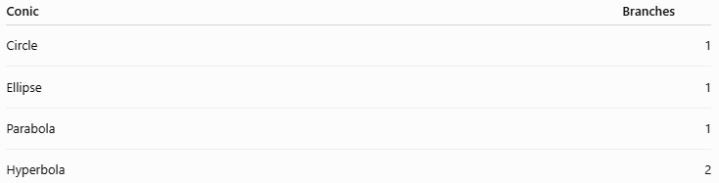
Conic | Branches
Circle | 1
Ellipse | 1
Parabola | 1
Hyperbola | 2
The hyperbola is unique among the four standard nondegenerate conics because it has two disconnected branches.

Symmetry
# Source: AI Source: Provided by: [Data Path: Persons Table -> ID Column: 1, Name_En Column: Motasem Essam] -> From: [ChatGPT] on [7/25/2026]
The four conics have different symmetry properties.
Circle
Has infinitely many reflection axes through its center and rotational symmetry of every angle.
Ellipse
Has two perpendicular reflection axes:
- major axis
- minor axis
and ${180}^{∘}$rotational symmetry.
Parabola
Has one reflection axis:
- axis of symmetry.
Hyperbola
Has two reflection axes:
- transverse axis
- conjugate axis
and ${180}^{∘}$rotational symmetry about its center.

Major Geometric Elements
# Source: AI Source: Provided by: [Data Path: Persons Table -> ID Column: 1, Name_En Column: Motasem Essam] -> From: [ChatGPT] on [7/25/2026]
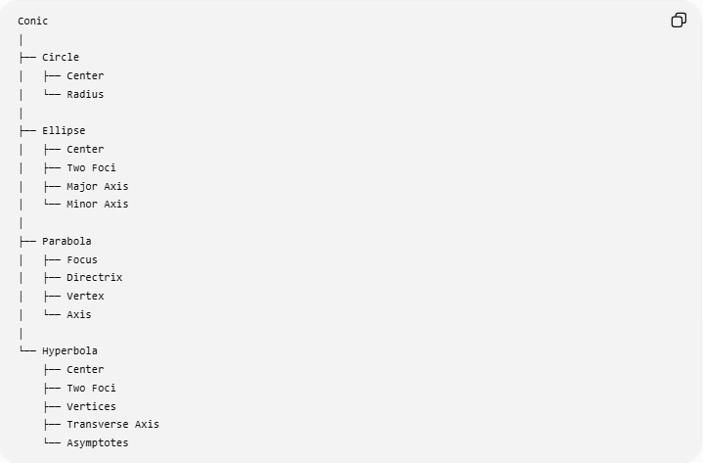
Conic
│
├── Circle
│ ├── Center
│ └── Radius
│
├── Ellipse
│ ├── Center
│ ├── Two Foci
│ ├── Major Axis
│ └── Minor Axis
│
├── Parabola
│ ├── Focus
│ ├── Directrix
│ ├── Vertex
│ └── Axis
│
└── Hyperbola
├── Center
├── Two Foci
├── Vertices
├── Transverse Axis
└── Asymptotes

Relationship Between $a$, $b$, and $c$
# Source: AI Source: Provided by: [Data Path: Persons Table -> ID Column: 1, Name_En Column: Motasem Essam] -> From: [ChatGPT] on [7/25/2026]
The ellipse and hyperbola have closely related parameters.
Ellipse
$$\boxed{c^{2}=a^{2}-b^{2}}$$
so:
$$\boxed{a^{2}=b^{2}+c^{2}}.$$
Hyperbola
$$\boxed{c^{2}=a^{2}+b^{2}}.$$
The difference is important:
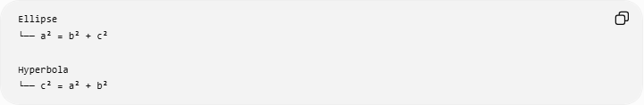
Ellipse
└── a² = b² + c²

Hyperbola
└── c² = a² + b²

Degenerate Conics
# Source: AI Source: Provided by: [Data Path: Persons Table -> ID Column: 1, Name_En Column: Motasem Essam] -> From: [ChatGPT] on [7/25/2026]
Not every quadratic equation produces a nondegenerate circle, ellipse, parabola, or hyperbola.
Under certain limiting or degenerate conditions, conic equations can produce objects such as:
- a point
- a pair of intersecting lines
- a pair of parallel lines
- a single line
- the empty set
For example:
$$x^{2}+y^{2}=0$$
has only:
$$\boxed{\left(0 , 0\right)}$$
as a real solution.
Thus, when discussing the four standard conics, we normally mean nondegenerate conics.

Conic Loci and Conic Sections
# Source: AI Source: Provided by: [Data Path: Persons Table -> ID Column: 1, Name_En Column: Motasem Essam] -> From: [ChatGPT] on [7/25/2026]
The word conic comes from conic sections: curves obtained by intersecting a plane with a double cone.
The same four fundamental curves appear:
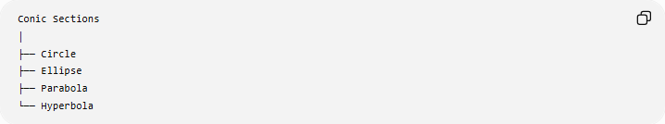
Conic Sections
│
├── Circle
├── Ellipse
├── Parabola
└── Hyperbola
The locus definition and the cone-intersection definition describe the same family of curves from two different geometric viewpoints.

Example — Identifying a Conic from Its Locus Condition
# Source: AI Source: Provided by: [Data Path: Persons Table -> ID Column: 1, Name_En Column: Motasem Essam] -> From: [ChatGPT] on [7/25/2026]
Suppose a problem states:
Find the locus of all points $P$such that the sum of the distances from $P$to two fixed points is $12$.
The condition is:
$$PF_{1}+PF_{2}=12.$$
A constant sum of distances means:
$$\boxed{\text{Ellipse}}.$$

Another example
# Source: AI Source: Provided by: [Data Path: Persons Table -> ID Column: 1, Name_En Column: Motasem Essam] -> From: [ChatGPT] on [7/25/2026]
Suppose:
$$∣PF_{1}-PF_{2}∣=12.$$
A constant difference means:
$$\boxed{\text{Hyperbola}}.$$

Another example
# Source: AI Source: Provided by: [Data Path: Persons Table -> ID Column: 1, Name_En Column: Motasem Essam] -> From: [ChatGPT] on [7/25/2026]
Suppose:
$$PF=d\left(P , l\right).$$
Equal distance from a point and a line means:
$$\boxed{\text{Parabola}}.$$

Another example
# Source: AI Source: Provided by: [Data Path: Persons Table -> ID Column: 1, Name_En Column: Motasem Essam] -> From: [ChatGPT] on [7/25/2026]
Suppose:
$$OP=5.$$
A fixed distance from a fixed point means:
$$\boxed{\text{Circle}}.$$

Complete Identification Table
# Source: AI Source: Provided by: [Data Path: Persons Table -> ID Column: 1, Name_En Column: Motasem Essam] -> From: [ChatGPT] on [7/25/2026]
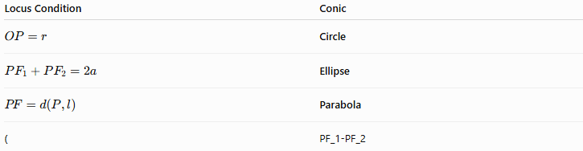
Locus Condition | Conic
$$OP=r$$ | Circle
$$PF_{1}+PF_{2}=2a$$ | Ellipse
$$PF=d\left(P , l\right)$$ | Parabola
( | PF_1-PF_2
This table is one of the most important summaries for conic loci.

Conic Loci Classification
# Source: AI Source: Provided by: [Data Path: Persons Table -> ID Column: 1, Name_En Column: Motasem Essam] -> From: [ChatGPT] on [7/25/2026]
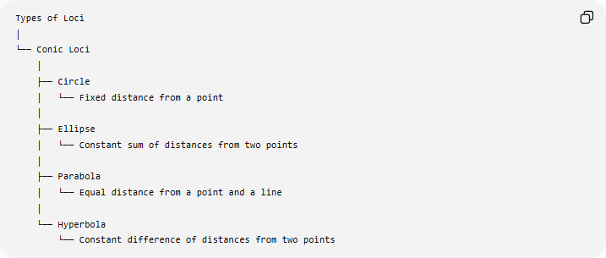
Types of Loci
│
└── Conic Loci
│
├── Circle
│ └── Fixed distance from a point
│
├── Ellipse
│ └── Constant sum of distances from two points
│
├── Parabola
│ └── Equal distance from a point and a line
│
└── Hyperbola
└── Constant difference of distances from two points

Broader Classification of Loci
# Source: AI Source: Provided by: [Data Path: Persons Table -> ID Column: 1, Name_En Column: Motasem Essam] -> From: [ChatGPT] on [7/25/2026]
Conic loci are only one part of the larger subject of loci.
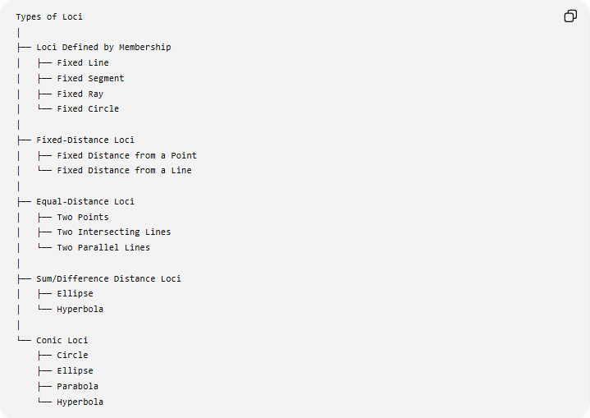
Types of Loci
│
├── Loci Defined by Membership
│ ├── Fixed Line
│ ├── Fixed Segment
│ ├── Fixed Ray
│ └── Fixed Circle
│
├── Fixed-Distance Loci
│ ├── Fixed Distance from a Point
│ └── Fixed Distance from a Line
│
├── Equal-Distance Loci
│ ├── Two Points
│ ├── Two Intersecting Lines
│ └── Two Parallel Lines
│
├── Sum/Difference Distance Loci
│ ├── Ellipse
│ └── Hyperbola
│
└── Conic Loci
├── Circle
├── Ellipse
├── Parabola
└── Hyperbola
Some categories overlap. For example, an ellipse is simultaneously a conic locus and a constant-sum distance locus.

Important Distinction: Conic Locus vs Conic Section
# Source: AI Source: Provided by: [Data Path: Persons Table -> ID Column: 1, Name_En Column: Motasem Essam] -> From: [ChatGPT] on [7/25/2026]
These terms are related but emphasize different definitions.
Conic Locus
Defines the curve through a geometric distance condition.
Example:
$$PF_{1}+PF_{2}=2a$$
defines an ellipse as a locus.
Conic Section
Defines the curve as the intersection of a plane with a cone.
Thus:
$$\boxed{\text{Locus definition}≠\text{Cone-section definition}}$$
but both describe the same conic curves.

Key Properties
# Source: AI Source: Provided by: [Data Path: Persons Table -> ID Column: 1, Name_En Column: Motasem Essam] -> From: [ChatGPT] on [7/25/2026]
The four fundamental conic loci can be summarized as follows:
$$\boxed{\begin{matrix}\text{Conic} & \text{Distance Rule} & \text{Closed?} & \text{Eccentricity} \\ \text{Circle} & OP=r & \text{Yes} & 0 \\ \text{Ellipse} & PF_{1}+PF_{2}=2a & \text{Yes} & 0<e<1 \\ \text{Parabola} & PF=d\left(P , l\right) & \text{No} & 1 \\ \text{Hyperbola} & ∣PF_{1}-PF_{2}∣=2a & \text{No} & e>1\end{matrix}}$$

Key Points
# Source: AI Source: Provided by: [Data Path: Persons Table -> ID Column: 1, Name_En Column: Motasem Essam] -> From: [ChatGPT] on [7/25/2026]
- Conic loci are geometric loci satisfying specific distance relationships.
- The four fundamental nondegenerate conics are:
$$\boxed{\text{Circle, Ellipse, Parabola, Hyperbola}}$$
- A circle uses a fixed distance from one point.
- An ellipse uses a constant sum of distances from two points.
- A parabola uses equal distance from a point and a line.
- A hyperbola uses a constant difference of distances from two points.
- Eccentricity provides another unified classification:
$$e=0, 0<e<1, e=1, e>1.$$
- Circle and ellipse are closed.
- Parabola and hyperbola are open.
- Hyperbola has two branches; the other three standard conics have one connected curve.
- Conic loci are closely related to, but conceptually distinct from, conic sections.

Conclusion
# Source: AI Source: Provided by: [Data Path: Persons Table -> ID Column: 1, Name_En Column: Motasem Essam] -> From: [ChatGPT] on [7/25/2026]
Conic loci are one of the most important families of geometric loci. They are characterized by precise distance relationships:
$$\boxed{\begin{aligned}\text{Circle}&→OP=r \\ \text{Ellipse}&→PF_{1}+PF_{2}=2a \\ \text{Parabola}&→PF=d\left(P , l\right) \\ \text{Hyperbola}&→∣PF_{1}-PF_{2}∣=2a\end{aligned}}$$
The central classification is therefore:
$$\boxed{\text{Distance Condition}⟶\text{Conic Locus}}$$
These four curves form the fundamental family of conic loci and provide a direct connection between classical Euclidean geometry, coordinate geometry, analytic geometry, and the theory of conic sections.

